Prescribing tip for information
Replacing a medication in EMIS Web
Did you know that it is possible to replace a therapy within EMIS Web rather than cancelling it & adding a new one?
This process is easy to do and is good for both safety (by avoiding the risk of accidental issue of the old therapy) and as system tidy up to avoid ‘sitters’ on a patient’s medical record. The Replace a Drug screen enables you to edit the drug details and provide a reason for replacing the drug, which is all audited in the Drug History. All replaced drugs are automatically moved to the Past Drugs screen and the Drug History includes the replacement drug details. If you opt to replace a drug when you have a consultation open for a patient, the replaced drug details will also populate in the consultation.
Here’s how to replace a medication ….
Open the patients Medication screen …
- Select Drug to be replaced
- Select ‘Replace’ on the Blue Ribbon at the top of the screen
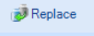
- The Current Drug is listed at the top of the replace a drug screen
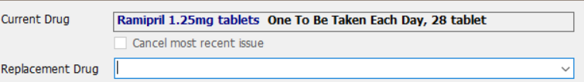
- Type in the new drug in the Replacement Drug field
- Select Replacement Drug from list, adding the relevant dose, quantity, and duration.
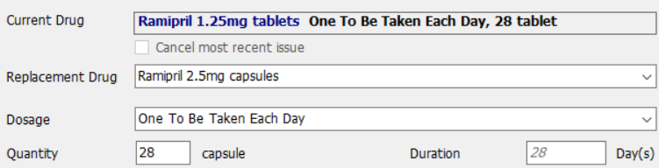
6.Click the ‘Replace Reason’ field to select one of the options from the dropdown list
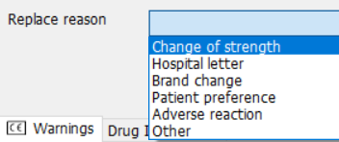
7.(Selecting ‘Adverse reaction’ requires you to select a code before issuing / Selection ‘Other’ requires you to complete the free text field before issuing)
8. Click on ‘Issue’ or ‘Issue later’
9. If you click on ‘Issue’ you are then required to select a Cancellation Reason for the drug that is being replaced
10. The Replaced Drug is then moved into Past Drugs
11. Select ‘Store’
12. Select ‘Approve & Complete’
Right click on the replaced drug to view the drug history. Any amendments are recorded in the drug history screen. Please note: - you cannot replace a drug that is still pending request.
Please note: the replace function is not appropriate for those patients on Repeat Dispensing. For those patients the original item will still need to be stopped and the remaining issues cancelled before a new therapy is added.
To contact the Medicines Optimisation Team please phone 01772 214302
If you have any suggestions for future topics to cover in our prescribing tips please contact Nicola.schaffel@nhs.net
All content accurate and correct on the date of issue of this tip.

